Session 8 WORK EDUCATION 30th March

Students are ready to complete their first module – GENERAL
(Reading was completed last week)
They are to log onto the website indicated on their handout www.education.vic.gov.au/safe@work/modules/industry/index.asp
If they have not finished reading – they are to do so under the general module tab (see snip below)
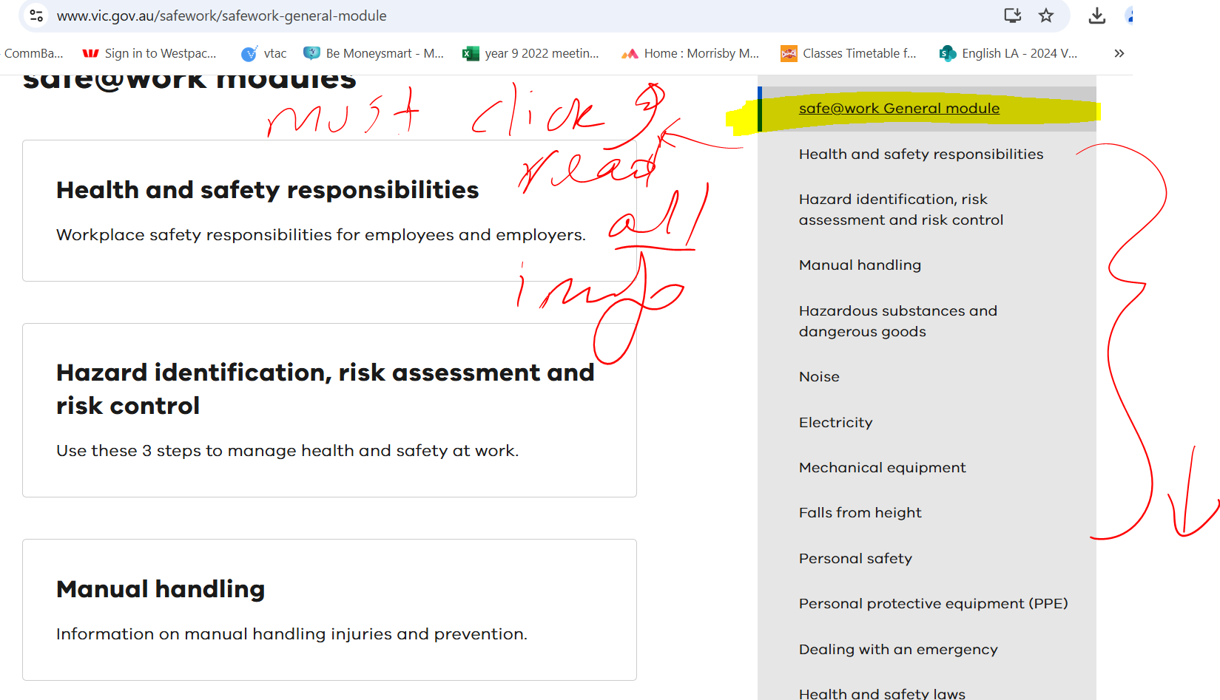

Once ready, they are to click onto the self-assessment tests tab (see below)
STEP 1
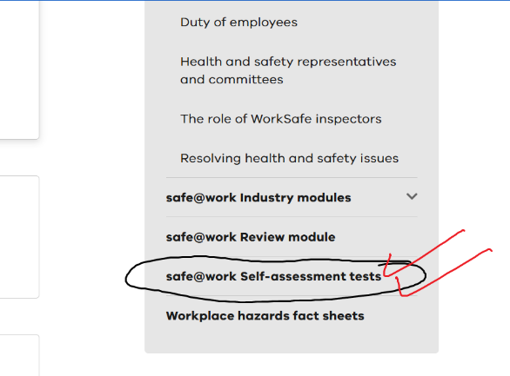
STEP 2
They are to click on to ‘start quiz’

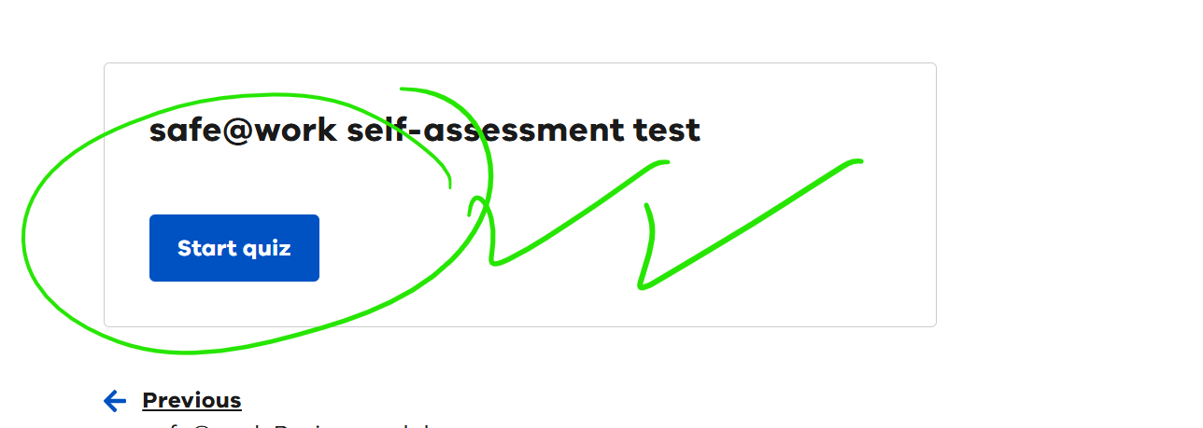

STEP 3
They are to fill in the required details and begin the test. Once successfully completed, they would gain a completed ‘General Module certificate’

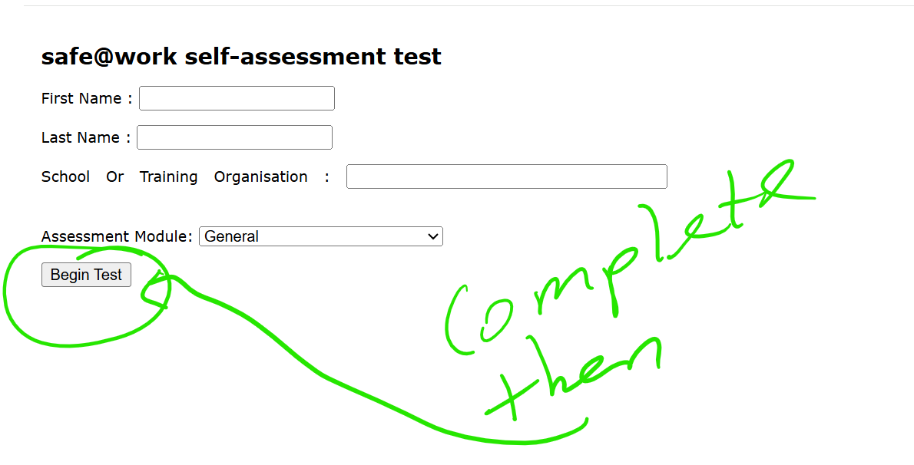

STEP 4
Save a copy of the General module and upload onto learning tasks
I have created a learning task for all students/classes.

Many Thanks

